* Title page – check website
* Abstract, introduction, methods, results, and conclusion in main text
* Main text file:
  + Title, abstract, and keywords;
    - Abstract should be no more than 200 words and contain the major keywords.
    - Provide three to six keywords.
  + Main text;
    - All text should be in 12-point font (Times Roman preferred), double-spaced and formatted to be US letter size (8.5 × 11 in).
  + References;
    - In-text citation – eg. Able and Charles 2014 / Frank et al. 2014
    - Alphabetical order
    - Eg. IUCN, Conservation International, and NatureServe. 2004. Global amphibian assessment. Available at www.globalamphibians.org. Accessed October 15, 2008.NOTE: The basic format for citing electronic resources is: Author's Last Name, First initial. Title of data package (e.g., Data from “Article name”). Data Repository Name, Data identifier (or DOI), address/URL.
  + Tables (each table complete with title and footnotes);
  + Figure legends;
  + Appendices (if relevant).
* Is there any evidence for genetic structure among the sampling localities?
  + Yes – 3 different genetic clusters – Mountain, North, South
* Does genetic variation follow a pattern of isolation-by-distance?
  + Yes – as shown in the correlogram
* Are there environmental features that are implicated in patterns of genetic structure?
  + Mountain range and river are barriers to gene flow > cause genetic structure
* Is there a risk of inbreeding?
  + Yes – A, B, and C have high Fis
* Do you see any patterns that reflect the PCoA results?
  + Yes, in the admixture plot and FstL
* Can this explain any patterns we may have observed?
  + Barrier to gene flow by mountain and river
  + Small isolated population in mountain group > inbreeding > genetic drift
* Look at FstL and PCoA – any pattern that reflect PCoA result?
  + Yes – they both support each other
* Include landscape information – can this explain any patterns we may have observed?
  + Yup – mountain and river serve as barriers
* Compare genetic and geographic distance
  + What can you conclude from the correlogram (spatial autocorrelation plot)?
    - Isolation by distance
  + What are the red dash lines?
    - Null hypothesis sample (if no isolation by distance)
  + What does the heterogeneity test tell us?
    - Low heterogeneity?
  + What is the null hypothesis?
    - That there is no isolation by distance
  + What does a significant result indicate?
    - There is isolation by distance
  + Which distance classes are significantly different from what we expect under a null model?
    - Some of them
* Given the landscape patterns and genetic structure observed, what traits do you expect this organism to have?
  + Cannot swim
  + Cannot cross mountain
* Discussion
  + A, B, and C form their own genetic cluster
  + Limited gene flow causes genetic cluster, and can cause genetic divergence
  + Literature supports – because bla bla finds that X hates climbing mountains so it makes sense that mountain range impedes gene flow
* Possible future work – can be suggested in the discussion
  + What are some other approaches that could help us better understand how environmental variables shape genetic variation?

Analysis:

* Sampling category:
  + Mountain: A to C
  + North: D to M (dataset 2a)
  + South: N to S (dataset 2b)
* Method category:
  + Genetic data – number of alleles, Ho, He, Fis (fixation index)
  + Genetic structure – pairwise Fst, PCoA, admixture structure – conclude 3 genetic groups and also estimated ne
  + Isolation by distance – correlogram
* HFP?
  + Effective number of alleles is less influenced by rare alleles
  + In our case, ne isn’t that important because we have the same number of samples at each site
  + If expected heterozygosity is less than observed, negative uHe
  + Can calculate deviation from HW
  + Site A to C have lower ne than the rest
  + Small isolated population - increase homozygosity - lower genetic variation - inbreeding depression - random genetic drift - positive fixation index
* FstL – pairwise Fst matrix
  + Large Fst - low gene flow - very different between site
  + Site A, B, and C are more divergent from other sites
  + Site A, B, and C appear to be more homozygous than expected - how?
    - Small isolated population - increase homozygosity - lower genetic variation - inbreeding depression - random genetic drift - positive fixation index?

|  |  |  |  |  |  |  |  |  |  |  |  |  |  |  |  |  |  |  |  |  |
| --- | --- | --- | --- | --- | --- | --- | --- | --- | --- | --- | --- | --- | --- | --- | --- | --- | --- | --- | --- | --- |
|  | **SiteA** | **SiteB** | **SiteC** | **SiteD** | **SiteE** | **SiteF** | **SiteG** | **SiteH** | **SiteI** | **SiteJ** | **SiteK** | **SiteL** | **SiteM** | **SiteN** | **SiteO** | **SiteP** | **SiteQ** | **SiteR** | **SiteS** |  |
| **SiteA** | 0.000 |  |  |  |  |  |  |  |  |  |  |  |  |  |  |  |  |  |  | **SiteA** |
| **SiteB** | 0.050 | 0.000 |  |  |  |  |  |  |  |  |  |  |  |  |  |  |  |  |  | **SiteB** |
| **SiteC** | 0.047 | 0.048 | 0.000 |  |  |  |  |  |  |  |  |  |  |  |  |  |  |  |  | **SiteC** |
| **SiteD** | 0.135 | 0.132 | 0.130 | 0.000 |  |  |  |  |  |  |  |  |  |  |  |  |  |  |  | **SiteD** |
| **SiteE** | 0.135 | 0.133 | 0.132 | 0.053 | 0.000 |  |  |  |  |  |  |  |  |  |  |  |  |  |  | **SiteE** |
| **SiteF** | 0.111 | 0.108 | 0.105 | 0.043 | 0.058 | 0.000 |  |  |  |  |  |  |  |  |  |  |  |  |  | **SiteF** |
| **SiteG** | 0.101 | 0.100 | 0.098 | 0.050 | 0.067 | 0.039 | 0.000 |  |  |  |  |  |  |  |  |  |  |  |  | **SiteG** |
| **SiteH** | 0.110 | 0.109 | 0.106 | 0.044 | 0.046 | 0.041 | 0.039 | 0.000 |  |  |  |  |  |  |  |  |  |  |  | **SiteH** |
| **SiteI** | 0.107 | 0.105 | 0.102 | 0.056 | 0.046 | 0.048 | 0.044 | 0.034 | 0.000 |  |  |  |  |  |  |  |  |  |  | **SiteI** |
| **SiteJ** | 0.097 | 0.095 | 0.092 | 0.074 | 0.077 | 0.051 | 0.041 | 0.054 | 0.053 | 0.000 |  |  |  |  |  |  |  |  |  | **SiteJ** |
| **SiteK** | 0.103 | 0.103 | 0.102 | 0.064 | 0.063 | 0.048 | 0.042 | 0.045 | 0.045 | 0.038 | 0.000 |  |  |  |  |  |  |  |  | **SiteK** |
| **SiteL** | 0.102 | 0.099 | 0.096 | 0.068 | 0.067 | 0.052 | 0.043 | 0.047 | 0.042 | 0.039 | 0.043 | 0.000 |  |  |  |  |  |  |  | **SiteL** |
| **SiteM** | 0.105 | 0.104 | 0.102 | 0.090 | 0.080 | 0.070 | 0.063 | 0.059 | 0.047 | 0.057 | 0.060 | 0.048 | 0.000 |  |  |  |  |  |  | **SiteM** |
| **SiteN** | 0.104 | 0.104 | 0.100 | 0.088 | 0.098 | 0.070 | 0.061 | 0.069 | 0.075 | 0.061 | 0.067 | 0.067 | 0.080 | 0.000 |  |  |  |  |  | **SiteN** |
| **SiteO** | 0.115 | 0.112 | 0.108 | 0.100 | 0.113 | 0.084 | 0.072 | 0.086 | 0.085 | 0.073 | 0.078 | 0.075 | 0.090 | 0.052 | 0.000 |  |  |  |  | **SiteO** |
| **SiteP** | 0.103 | 0.100 | 0.098 | 0.082 | 0.097 | 0.067 | 0.053 | 0.070 | 0.072 | 0.056 | 0.066 | 0.062 | 0.079 | 0.055 | 0.053 | 0.000 |  |  |  | **SiteP** |
| **SiteQ** | 0.113 | 0.110 | 0.108 | 0.093 | 0.111 | 0.079 | 0.064 | 0.083 | 0.083 | 0.067 | 0.075 | 0.073 | 0.090 | 0.061 | 0.046 | 0.040 | 0.000 |  |  | **SiteQ** |
| **SiteR** | 0.136 | 0.135 | 0.132 | 0.101 | 0.118 | 0.091 | 0.076 | 0.095 | 0.095 | 0.083 | 0.093 | 0.086 | 0.109 | 0.094 | 0.091 | 0.057 | 0.065 | 0.000 |  | **SiteR** |
| **SiteS** | 0.115 | 0.114 | 0.109 | 0.091 | 0.108 | 0.076 | 0.062 | 0.081 | 0.083 | 0.069 | 0.077 | 0.072 | 0.091 | 0.070 | 0.066 | 0.043 | 0.048 | 0.046 | 0.000 | **SiteS** |
|  | **SiteA** | **SiteB** | **SiteC** | **SiteD** | **SiteE** | **SiteF** | **SiteG** | **SiteH** | **SiteI** | **SiteJ** | **SiteK** | **SiteL** | **SiteM** | **SiteN** | **SiteO** | **SiteP** | **SiteQ** | **SiteR** | **SiteS** |  |

* PCoA
  + Site A B C cluster themselves - no gene flow with others
  + The other cluster - have some other clusters too
  + PCoA - there are free groups - Site A, B, and C form their own group - also supported by Fst





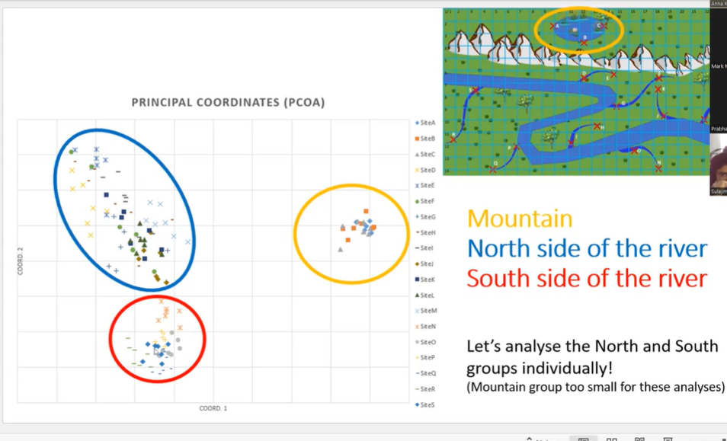

* Feature of landscape
  + Feature of landscape that might restrict gene flow - barriers such as water, bio-interaction such as predation - most straightforward is simply geographic distance (isolation by distance) - can cause genetic divergence

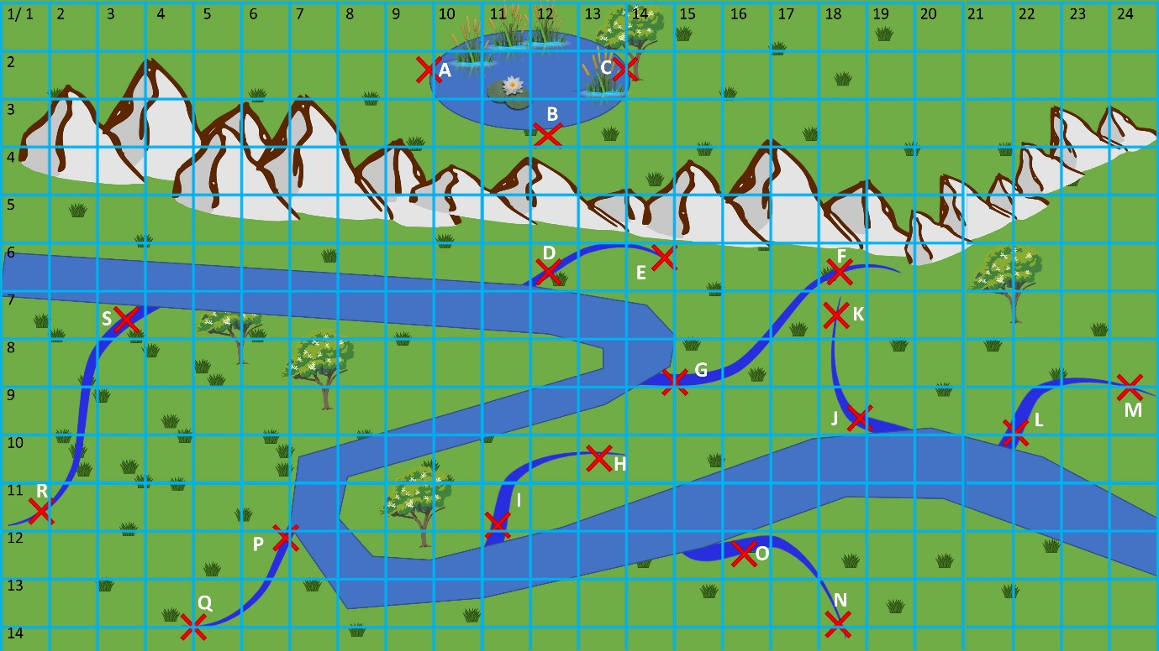

* Genetic and geographic distance
  + y-axis the genetic similarity
  + x-axis - geographic distance category
  + average value of genetic similarity and 95%CI for each distance category
  + Blue - the shape of the distribution of the genetic similarity across the distances
  + Red dashed line - encompasses a random distribution - 95%CI when you just grab random individuals a thousand time within those bounds
  + Positive correlation – significantly higher genetic similarity
  + Negative correlation – significantly lower genetic similarity
  + If get a sharp decline - constraint on which individuals can disperse to from their place of birth - high relatedness among the individuals of that location so decline rapidly when move from that distance



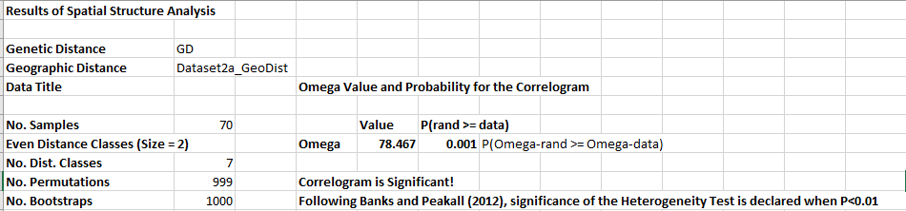

* + Dataset 2a – north pop – genetic similarity decreases as the distance increases
  + Correlogram is Significant!
  + Heterogeneity is significantly lower
  + Isolation by distance



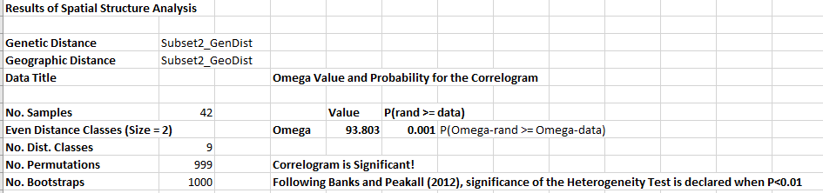

* + Dataset 2b – south pop – north pop – genetic similarity decreases as the distance increases
  + Correlogram is Significant!
  + Heterogeneity is significantly lower
  + Isolation by distance
  + Can use the table below the graph to make pairwise comparisons of distance classes in each dataset eg. distance class 1 vs 12
  + If the tribute trees (?) are a barrier, we will see a steeper decline in the correlogram
* Admixture
  + 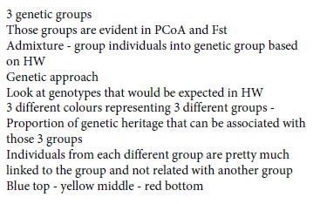

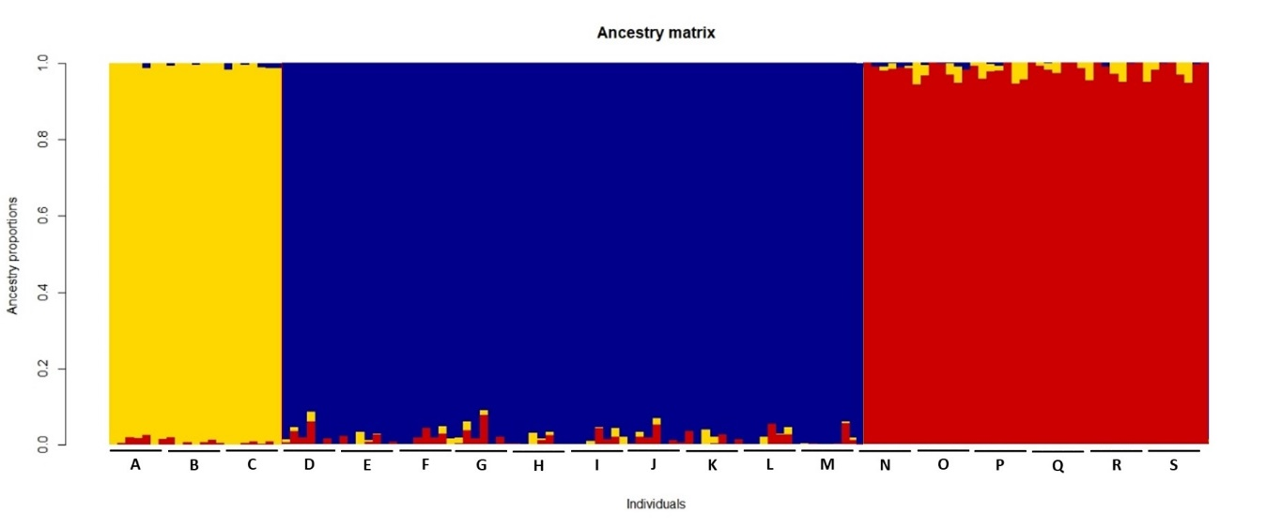

* Questions
  + Title page and ethic statement